# Assignment 2

## P2

### What are organisational policies and procedures?

Organisational polices and procedures are created by companies in order to streamline and standardise business processes for maximum efficiency and resiliency. Computer systems can be used to assist in the automation of these procedures in whole or in part. Some processes such as creating a standard letter would merely involve the creation of a word processing template which all employees could use. While other procedures such as inventory tracking would require the creation or purchase of highly specialised configurable software (e.g. ERP software).

Should the business environment change it is likely that these policies and procedures would have to change to. The speed and ease with which this can be done is called and organisations “agility”. Complex IT systems can be hard and costly to change.

In practice IT departments have limited resources. This means that if a small selection of standardised equipment such as hardware from one manufacturer is easier and cheaper to support than a diverse range. IT departments tend to have lists of certain applications that you can put on your computer that both the user and the technical support team have agreed.

### So what are the impacts of this?

Limiting supported products reduces the knowledge set of IT support so that they can become experts in each item, thus resulting in faster more efficient fixes to the vast majority of problems. This policy also reduces training costs thus contributing to the reduction of overall costs (Total Cost of Ownership – TCO).

Limiting the list of supported products can hinder the progress of unusual tasks by not allowing you to have specific applications that allow the task to be completed in a fast and efficient way. If this task or others of its type are likely to be more frequent, then the IT department can consider reviewing the software and adding it to their list of supported items.

Other aspects of IT support management policies include;

## Case Severity Levels

There are different levels of severity when replying and dealing with customer support and these are what our company has put as its desired levels of severity.

|  |  |
| --- | --- |
| Severity Level | Definition |
| Critical | * Problems or issues in the software/service that interrupt or prevent the entire customer population from performing regular business operations. * Problems or issues caused by the software/service having a catastrophic impact on regular business operations. |
| High | * Problems or issues in the software/service that interrupt or prevent a significant percentage of the customer population from performing regular business operations. * Problems or issues caused by the software/service having a major impact on regular business operations. |
| Medium | * Problems or issues in the software/service that interrupt or prevent a small percentage of the customer population from performing regular business operations. * Problems or issues caused by the software/service having a significant impact on regular business operations. |
| Low  Low | * Problems or issues in the software/service that interrupt or prevent an individual user from performing regular business operations. * Problems or issues having a minor impact on regular business operations. * Information requests. |

### Service level agreements (SLA)

Service level agreements are formal documents that specify the response times and escalation pathways for problems. They also include details of management responsibility at different levels of the problem response. Typically faster responses to problems are reflected by increased costs.

Confidentiality and sensitivity

Confidentiality and sensitivity of company data may be important depending on the nature of the business. Employees may be required to have confidentiality clauses in their contracts or may be required to sign nondisclosure agreements (NDAs). In practice this is likely to affect IT staff who are required to work on computers containing organisational data or employee documents which contain confidential or sensitive information. Disposal of IT assets must also take into account removal and erasure of confidential and sensitive data.

## P3

### What types of faults can occur?

Types of faults include:

* Hardware:
  + Hard disk
  + Memory
  + CPU/Motherboard
  + Display
  + Keyboard/Mouse
  + Other expansion card or peripheral
  + Printer
* Software:
  + Installation errors
  + Configuration errors
  + User error/lack of training
  + Document corruption
* Network:
  + Faulty cables
  + Faulty routers/hubs
  + IP configuration problems
  + Firewall configuration
* System administrative problems:
  + Forgotten passwords
  + Users not assigned correct permissions

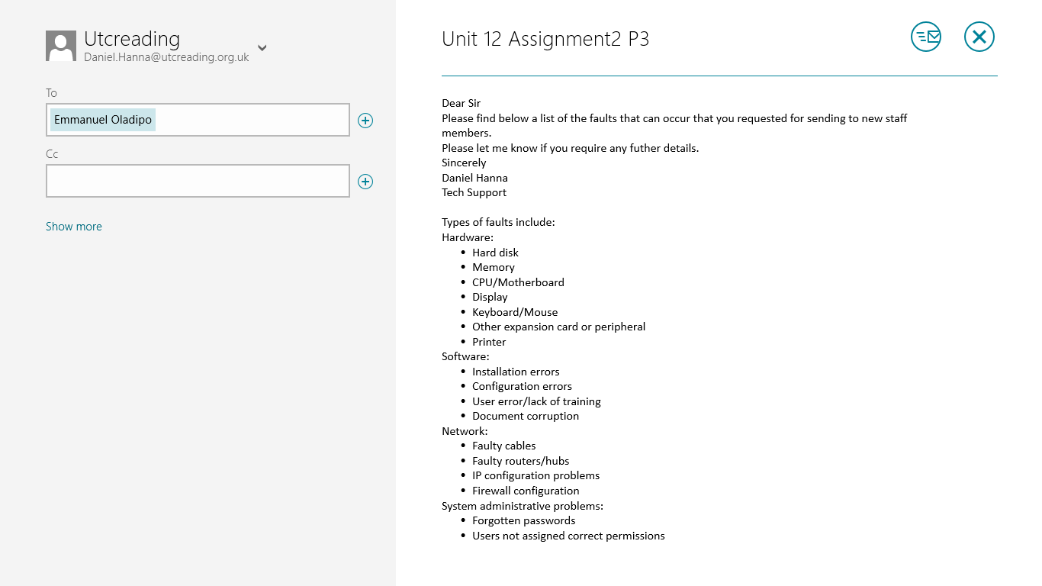

## M2

What is outsourcing? Outsourcing is act of subcontracting a business function in whole or in part to a third party.

### What are the advantages of outsourcing?

The main advantage is that the organisation doing the outsourcing can reduce labour costs and employee headcount. It also allows them to have more predictable costs when creating a budget. SLAs also allow both parties to specify the exact level of response required for problems. This allows outsourcing companies to adopt follow-the-sun support policies on a global scale. They can also use programs to remotely change the programing of the network or even troubleshoot computers using remote desktoping.

### What are the disadvantages of outsourcing?

The disadvantages is that the technical support team can only be there in voice, video or remote desktoping but they can’t fix physical problems without telling you what to do. Another disadvantage is that they can’t always be available if they in a different time zone which can be quite problematic in a business environment, but this can be fixed using the follow-the-sun support policy or shift work in other time zones. Further disadvantages may be non-English speakers and may be subject to different employment laws or social expectations. Outsourcing can move jobs from one place or country to another reducing local job opportunities, this can cause resentment in the community that was affected by the move.

## Evaluation

### Outsourcing

Outsourcing can cause possible damage to customer satisfaction due to people wanting to talk to someone who can speak their mother tongue clearly, an example of this is a few years ago a Bank outsourced all of their customer support to India and this cause a lot of problems with people not understanding what the Indian customer supporters were trying to tell them.

### In-house

Keeping your customer support etc. in the same country as your business can be very costly as people who live for example in the UK are paid quite high salaries verses someone who lives in India, but there is a higher probability that you will get a high level of expertise in your home country.

Some companies use partial outsourcing to handle the more straightforward work and then get the outsourced workers to send the handle exceptions or the more challenging problems to in-house workers.